1. **Mediastack (https://mediastack.com):**

Covers 7500+ news websites for 50+ countries in 13 languages.

Plans: Please refer this website for the same (https://mediastack.com/pricing)

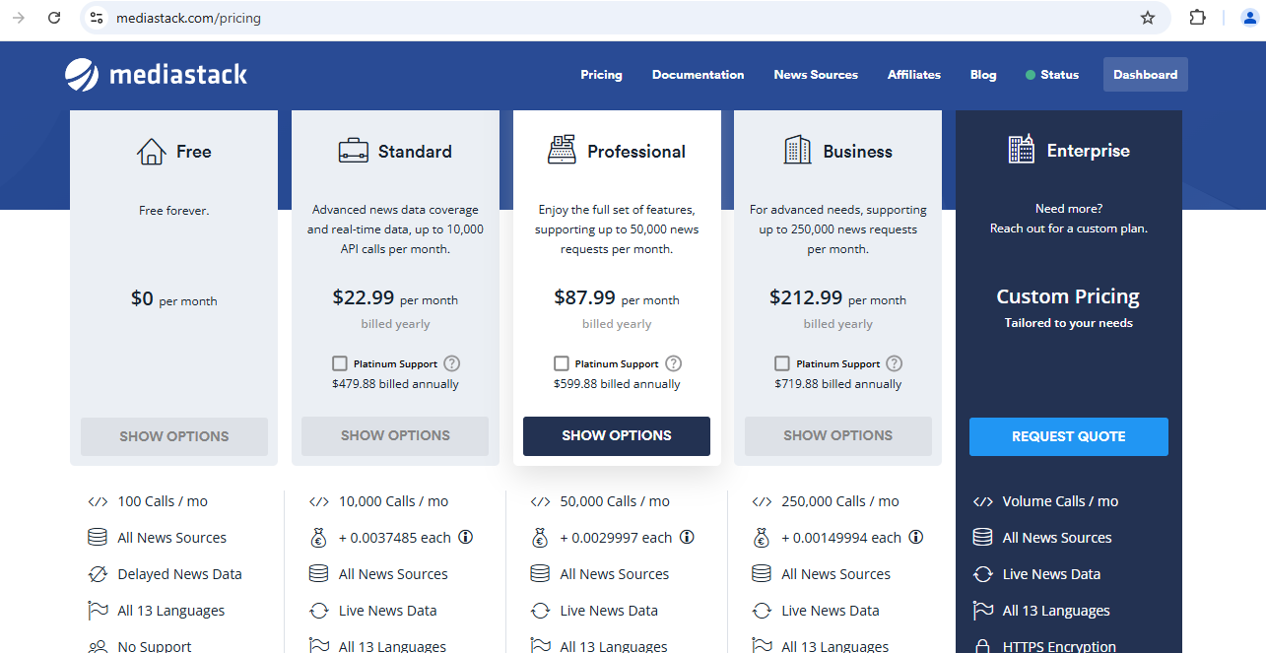

1. **Newsapi (**[**https://newsapi.org/**](https://newsapi.org/)**)**

Covers 150,000 news wesbites from 50+ countries in 13 different languages.

Plans: Please refer this website for the same (<https://newsapi.org/pricing>)

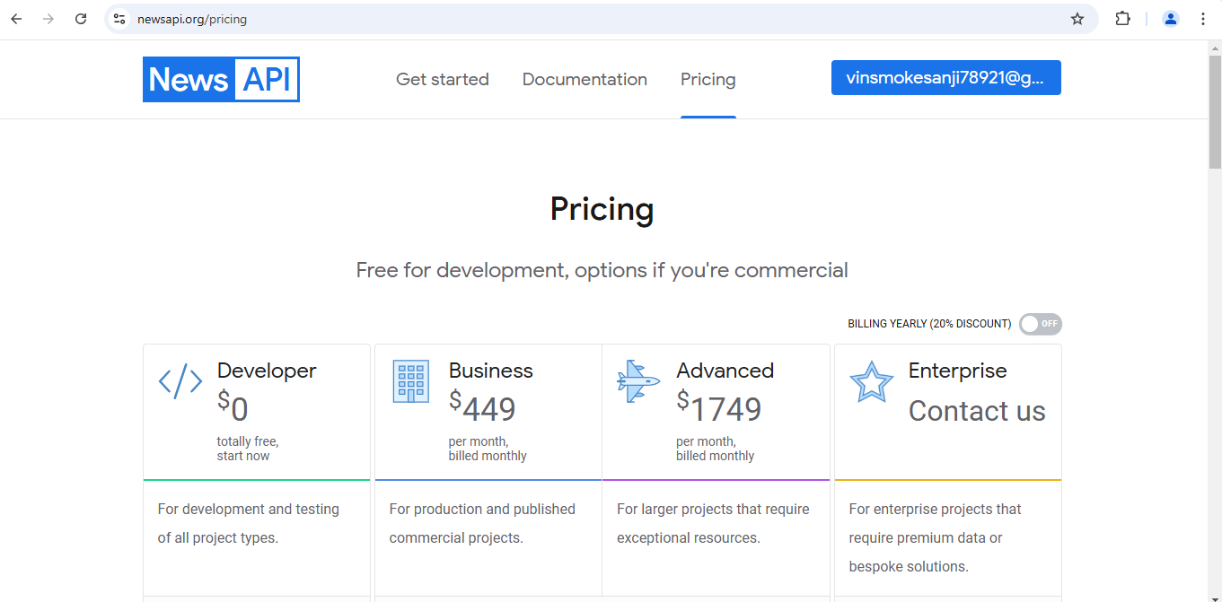

1. **Apify (https://apify.com/):**

For social media posts and descriptions.

Covers twitter, Instagram, linkedin.

Plans: Pay-as-u-go plan. (<https://apify.com/pricing>)

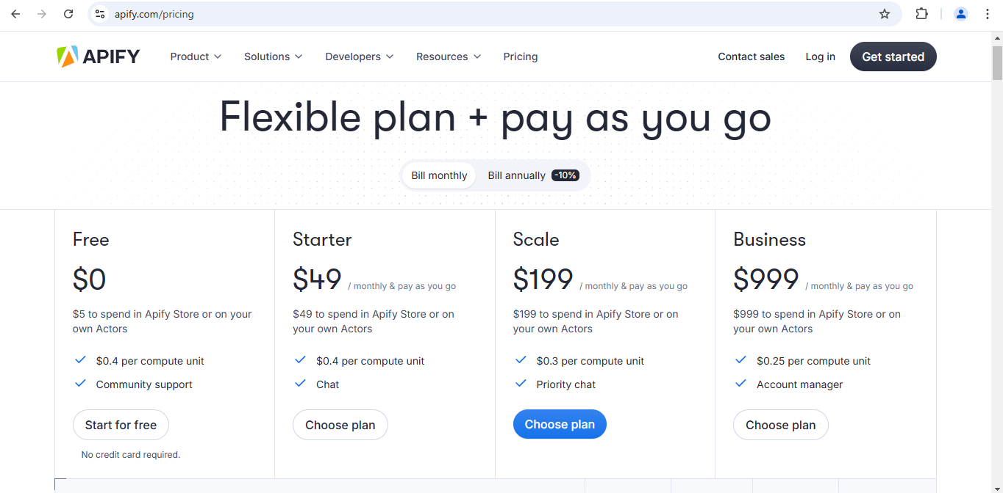

1. **WhatsApp API: (https://business.whatsapp.com/products/platform-pricing?country=India&currency=Indian%20Rupee%20(INR)&category=Marketing)**

|  |  |  |  |  |  |  |
| --- | --- | --- | --- | --- | --- | --- |
| Market | Currency | Marketing | Utility | Authentication | Authentication-  International | Service |
| India | Rs. | 0.7846 | 0.115 | 0.115 | 2.3 | 0 |

1. **Twilio: (https://www.twilio.com/en-us/whatsapp/pricing)**

